CREATIONS OF TABLES :
1. HotelBookings
Columns used: BookingID, DateID, RoomNumber, CustomerID, BranchID, TotalAmount, CheckIn, CheckOut, Nightstay, Purpose, StayType, Paymentmethod, Bookingstatus
Formulas used:
- Nightstay = CheckOut - CheckIn
- StayType = =IF(I2=0,"Day Use",IF(I2<=2,"Short Stay",IF(I2<=4,"Medium Stay","Long Stay")))
- TotalAmount = =VALUE(SUBSTITUTE(VLOOKUP(C2, Room!A:F, 5, FALSE), "₹ ", "")) * I2
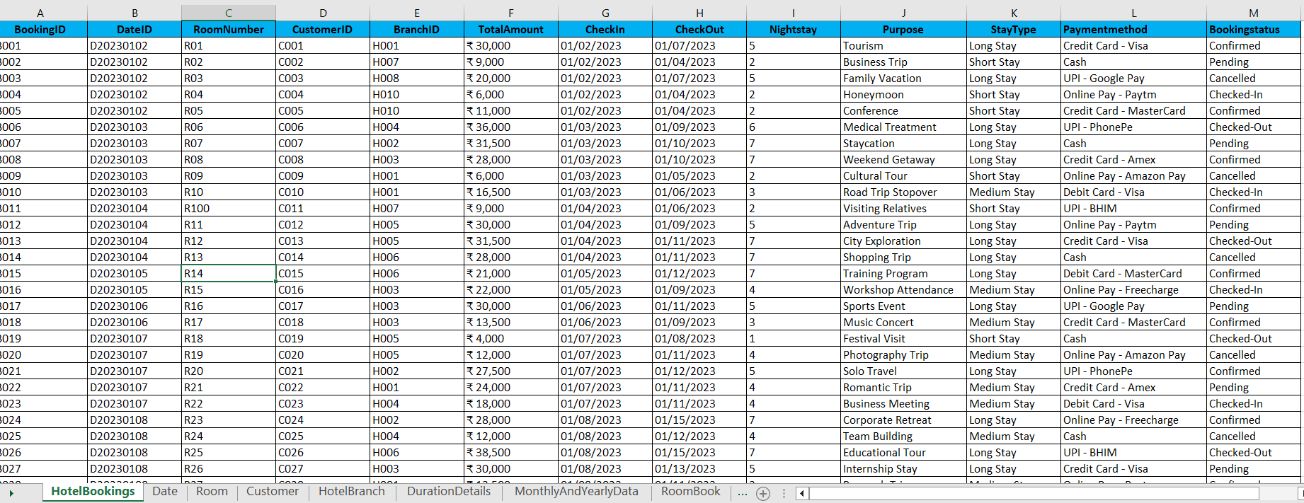
2. Date
Columns used: DateID, Date, Day, Month, Year, Weekday, WeekStartDate, WeekEndDate
Formulas used:
- Day = DAY(B2)
- Month = TEXT(B2, "MMMM")
- Year = YEAR(B2)
- Weekday = TEXT(B2, "dddd")
- WeekStartDate = B2 - WEEKDAY(B2, 2) + 1
- WeekEndDate = B2 - WEEKDAY(B2, 2) + 7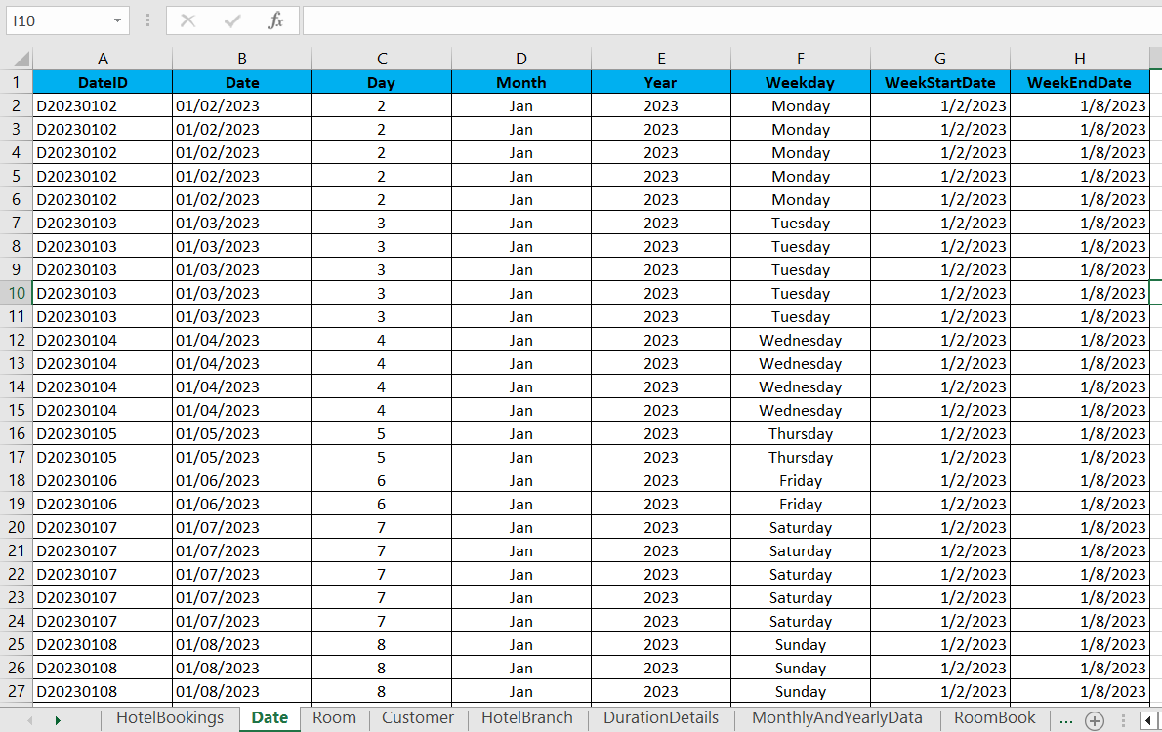

3. Room
Columns used: RoomID, RoomType, BedType, Capacity, PricePerNight, Room_Category
Formulas used:
- BedType=IF(B2="Suite","King",IF(B2="Executive","Queen",IF(B2="Deluxe","Queen",IF(B2="Standard","Double", IF(B2="Premium","King","")))))
- PricePerNight="₹"&IF(B2="Suite",6000,IF(B2="Executive",4500,IF(B2="Deluxe",4000,IF(B2="Standard",3000, IF(B2="Premium",5500,"")))))
- RoomCategory=IF(B2="Suite","Premium",IF(B2="Executive","Mid-range",IF(B2="Deluxe","Mid-range", IF(B2="Standard","Budget",IF(B2="Premium","Premium","Other")))))
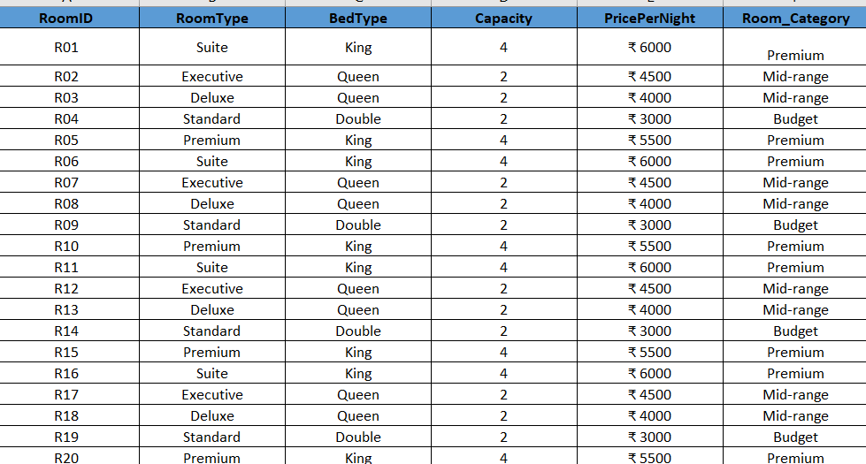
4.Customer
Columns used:CustomerID, Name, Gender, Age, LoyaltyTier, Country, RoomNumber
Formulas used:
- LoyalityTier:=IF(D2>=50,"Platinum",IF(D2>=30,"Gold","Silver"))
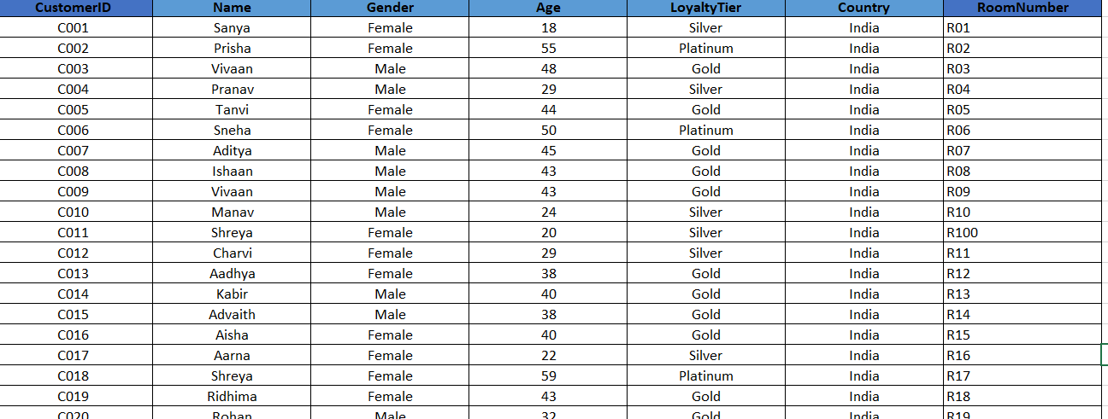

5.HotelBranch
Columns Used:BranchID, BranchName, City, State, Country, StarRating
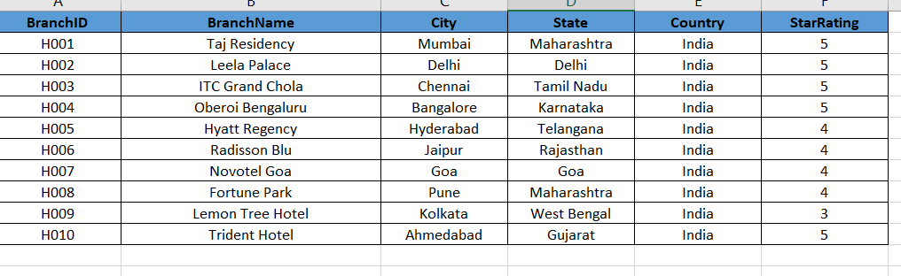
6.DurationDetails
Columns Used: BookingID, Name, CheckIn, CheckOut, DurationDays, TotalAmount, DailyRevenue
Formulas Used:
- DurationDays = CheckOut - CheckIn
- DailyRevenue = TotalAmount / DurationDays
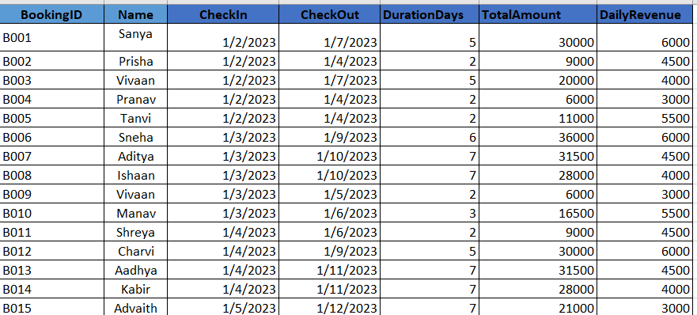
6.MonthlyAndYearly
Columns Used: MonthStart, MonthEnd, MonthName, Year, MonthLabel, DayCount, RoomsAvailable, Quarter, Season, NextMonth
Formulas used:
- MonthStart (A2) =DATE(D2, MONTH(C2 & " 1"), 1)
- MonthEnd (B2) =EOMONTH(A2, 0)
- MonthName (C2) =TEXT(A2, "MMMM")
- Year (D2) =YEAR(A2)
- MonthLabel (E2) =TEXT(A2, "MMM YYYY")
- DayCount (F2) =DAY(EOMONTH(A2, 0))
- Quarter (G2) ="Q" & ROUNDUP(MONTH(A2)/3, 0)
- Season =IF(OR(C2="Dec",C2="Jan",C2="Feb"),"Winter",IF(OR(C2="Mar",C2="Apr",C2="May"),"Summer",IF(OR(C2="Jun",C2="Jul",C2="Aug"),"Rainy","Autumn")))
- NextMonth (I2) = EOMONTH(A2, 1) + 1
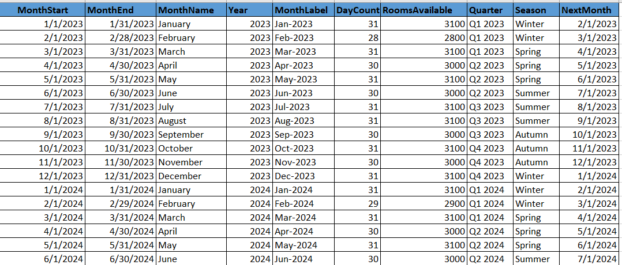
7.RoomBook
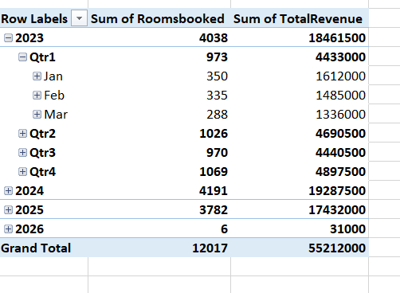
8.RoomBookCount
Columns Used: Staydate, Roomsbooked, TotalRevenue
Formulas Used:
- Roomsbooked =COUNTIFS(DurationDetails!$C:$C,"<="&A2,DurationDetails!$D:$D,">"&A2)
- TotalRevenue =SUMIFS(DurationDetails!$G:$G, DurationDetails!$C:$C, "<=" & A3, DurationDetails!$D:$D, ">" & A3)
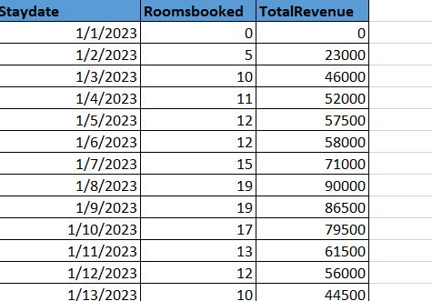
9.MaterData
Columns Used:MonthStart, MonthLabel, StayDate, RoomAvailableCount, RoomSoldCount, TotalRevenue, Occupancy %, ADR, RevPAR
Formulas Used :
- Occupancy % (G2) =E2 / D2
- ADR (Average Daily Rate) (H2) =F2 / E2
- RevPAR (Revenue per Available Room) (I2) =F2 / D2
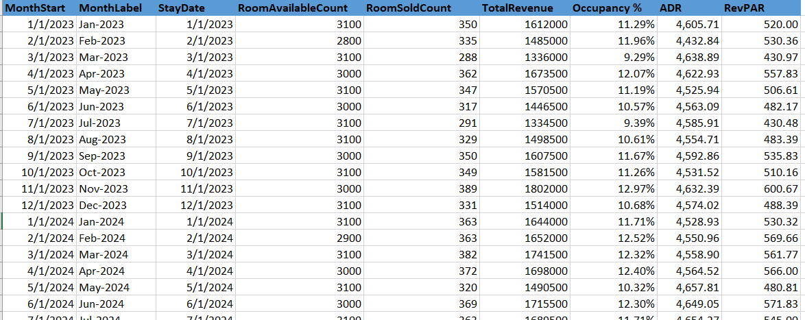
10.tbl_calculations
Columns Used:MonthStart, MonthLabel, StayDate, RoomAvailableCount, RoomSoldCount, TotalRevenue, Occupancy %, ADR, RevPAR, Quarter, Season
Formulas Used :
- Occupancy % (G2) =E2 / D2
- ADR (H2) =F2 / E2
- RevPAR (I2) =F2 / D2
- Quarter (J2) ="Q" & ROUNDUP(MONTH(C2)/3, 0)
- Season (K2)
=IF(OR(MONTH(C2)=12,MONTH(C2)=1,MONTH(C2)=2),"Winter",IF(OR(MONTH(C2)=3,MONTH(C2)=4,MONTH(C2)=5),"Summer",IF(OR(MONTH(C2)=6,MONTH(C2)=7,MONTH(C2)=8),"Rainy","Autumn")))
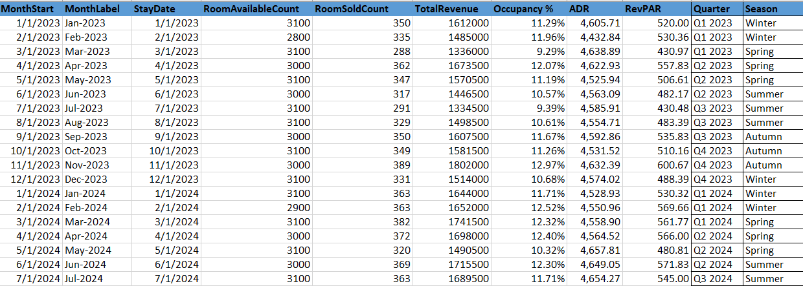
11.tbl_Bookings
ColumnsUsed:
StayDate, BookingID, CheckIn, CheckOut, CustomerID, RoomNumber, DurationDays, TotalAmount, DailyRevenue,
Formulas Used :
- DurationDays (G2) =D2 - C2
- DailyRevenue (I2) =H2 / G2
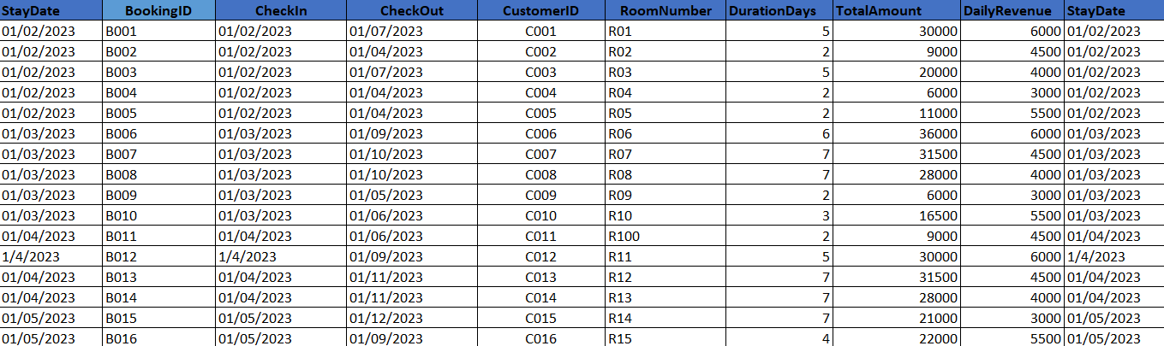
12.tbl_rates
Columns Used:RoomID, RoomType, PricePerNight
Formulas Used :
- PricePerNight:="₹ "&IF(B2="Suite",6000,IF(B2="Executive",4500,IF(B2="Deluxe",4000,IF(B2="Standard",3000,
IF(B2="Premium",5500,"")))))
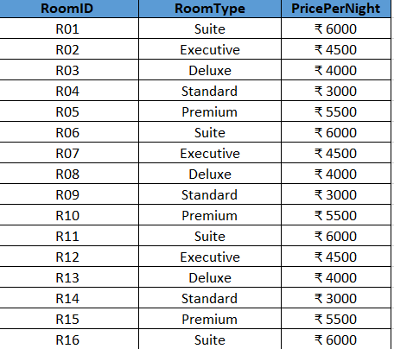

VISUALISATIONS 